# Iteration #1

Use case implementation

**Goal with iteration**

Be able to use use-cases (add, edit, search).

Add book – should be able to add a non-existent book to booklist

Edit book – should be able to edit an existing book.

Search book – should be able to search book by author or title.

**Use Cases**

Add Book

Requirements – add book to booklist, id of book should be generated

Feature list – only add non-existing book i.e. no other book should exist with same title and author

External requirement – search book (to check if book exist or not)

Design implementation – check image 1

Estimated time: 15min

Achieved time: 11min

Edit Book

Requirements – update book info to booklist, only existing book can be updated (existing books are determined by its unique id).

External requirement – GetBook use case

Design implementation – check image 2

Estimated time: 15min

Achieved time: 34min

Search book

Requirements – search book by title

Feature list – be able to search book by author too

Design implementation – check image 3

Estimated time: 15min

Achieved time: 15min (pretty decent estimation)

Image 1



Image 2

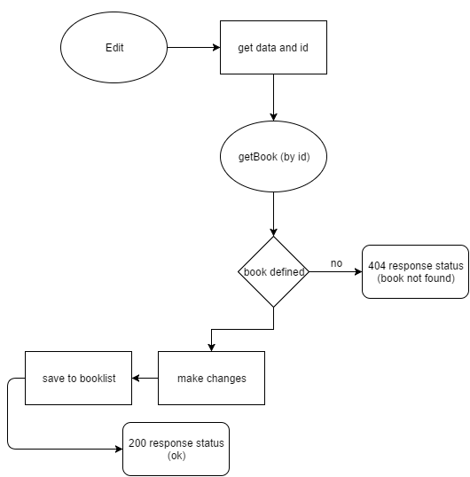

Image 3

